Art Snow Packets #6-10 (Sculpture)

For this week of assignments, you will be creating an abstract sculpture out of any materials you choose. You can stick with one type of item (such as crayons), or you can do a mash-up of multiple types of items (like crayons, old socks, and paper clips) together.
This is simply supposed to be an interesting sculpture made out of any items you have laying around your house that you would like to see attached together in some way. It does not matter how you attach the pieces, but I recommend hot glue if you have it available. If you don’t have hot glue and are worried about getting heavy items to stick together, just use lightweight materials such as paper or flowers and use tape to attach them. Use what you already have.
The finished sculpture needs to be at least 12 inches tall or wide (so it doesn’t have to go 12 inches straight up, it could be 12 inches long while laying down). The total time that needs to be put into your sculpture should be at least 5 hours (1 hour per each snow packet day). I will be able to tell if you put effort into this, and it is a grade of 100 points, so do your best. This should be a fun project, so don’t stress and just start to assemble random objects together to see what happens.

Examples for Inspiration:
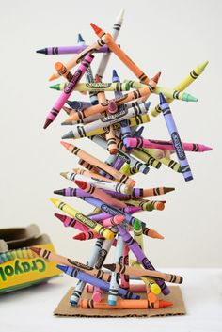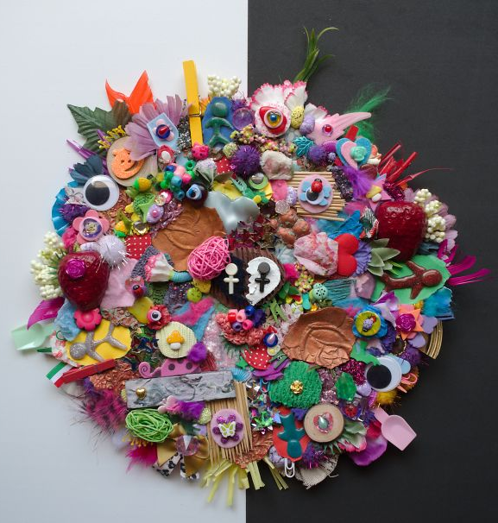
Made from just Crayons Made from tons of toys, googly eyes, junk, etc.

