Art Snow Packet #11-16 (Sculpture)

You have two different subtractive sculpture assignments for this week. Subtractive sculpture simply means that you create by taking material away from the original object. In this case, you will be carving and cutting material away to create two different sculptures- one made from soap and one made from foam. Both of these materials are very soft and easy to work with, but subtractive sculptures can be made of other harder materials like wood and stone. You should spend about 2-3 hours on the soap and about 3-4 hours on the foam.

Day #11, 12: Soap Sculpture
You will need to create an animal out of your bar of soap. I want it to be a full body, not just an animal head. I have provided two bars of soap for you just in case of a mistake, but I only need you to create one sculpture to turn in. The only tool you need for this is a paper clip to carve away the soap. Try to make your sculpture as detailed as possible. I realize this will be a bit difficult at first, but you will get the hang of it as you go. Practice on one bar of soap before working on your final. I am not looking for perfection, but I want to be able to see that you tried and spent some time on your sculpture.
Examples:
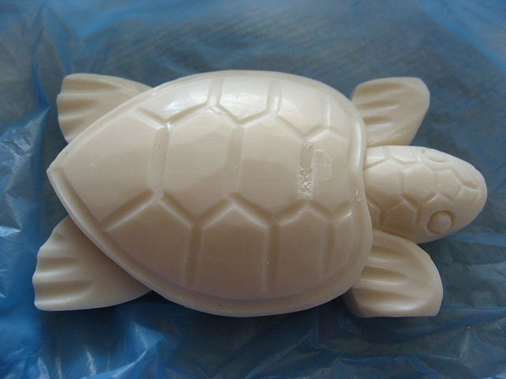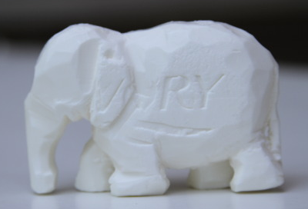

Day #13, 14, 15, 16: Foam Sculpture
You will need to create an abstract sculpture out of your block of foam. I am not sure which tools will work best, but you can try scissors, a knife, sandpaper, or really anything you want to try. I want you to make something that looks interesting. Look up Floral Foam sculptures online for inspiration if you want to. Again, I’m not looking for perfection; I just want to see that you tried.
Example:
