High School P.E. Snow Packet Days 6-10

Name:

Snow Packet Day 6-7
Complete Activities
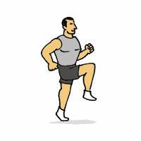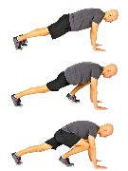
Run in place 5 min lunges 5 minutes Sit-ups 3 sets of 10 Mountain climbers 3 sets of 10

Student Signature: Parent Signature:

Snow Packet Day 8-9
Complete Activities
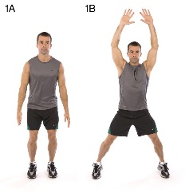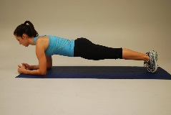
Run in place 7 min Leg lifts 3 sets 1 min Jumping Jacks 3 sets of 30 Planks 3 sets of 60 sec.

Student Signature Parent Signature

Snow Packet Day 10
Complete Activities
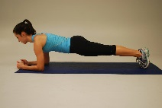
30 Squats jumping jacks 3 sets of 45 Mountain Climbers 3 sets of 40 Situps 3 sets 20
Student Signature: Parent Signature:

