Work Packets 27-31
English 12

***Put your full header at the top of this page**

Monday: Read all of the enclosed AP information. Follow the packet instructions to complete the computer check if you plan to test remotely. Message me and let me know where you are testing if you haven’t already.

Tuesday: Look back at your notes about breaking down a prompt. Read the 2 prompts I have given you “Test Prep Sample Prompts” and break them down like we practiced in class. Write under each prompt, in your own words, exactly what you would need to address in your essay to get a high score.

Wednesday: Look at the example essay I have printed. It is a response to prompt #1 from yesterday. This is an extremely high scoring rhetorical analysis essay. Look at the worksheet “What should a rhetorical analysis essay do?” and match each requirement to where you see it in the sample essay. Cite (by paragraphs) where in the essay you find each element on that worksheet.

Thursday: Read the “AP Test Practice Essay” prompt and excerpt. Go through and annotate the excerpt like we practiced in class, marking the parts you plan to use as evidence.

Friday: Write your rhetorical analysis essay. It is best to time yourself and spend no more than an hour on this, as you should be preparing for the timed environment of the exam in May.

You may also type and submit the essay to me at charity.jones@k12.wv.us

Test Prep Sample Prompts

1. The United States participation in the Second World War began in 1941 and lasted until the Axis powers surrendered in 1945. During that period, on September 24, 1942, Congresswoman Clare Boothe Luce delivered the following address, “The Role of American Women in Wartime,” to a women’s banking committee. Read the passage carefully. Write an essay that analyzes the rhetorical choices Luce makes to convey her message that women needed to prepare to make more sacrifices as the war effort continued.

2. The following passage is biologist Hope Jahren’s prologue to her 2016 memoir Lab Girl. A prologue is an introduction that provides background information to set the context for a literary work. Jahren uses this prologue to give a basic understanding of the kind of work she does and why she considers it to be important. Read the passage carefully. Write an essay that analyzes the rhetorical choices Jahren makes to convey the message of the importance of her work.

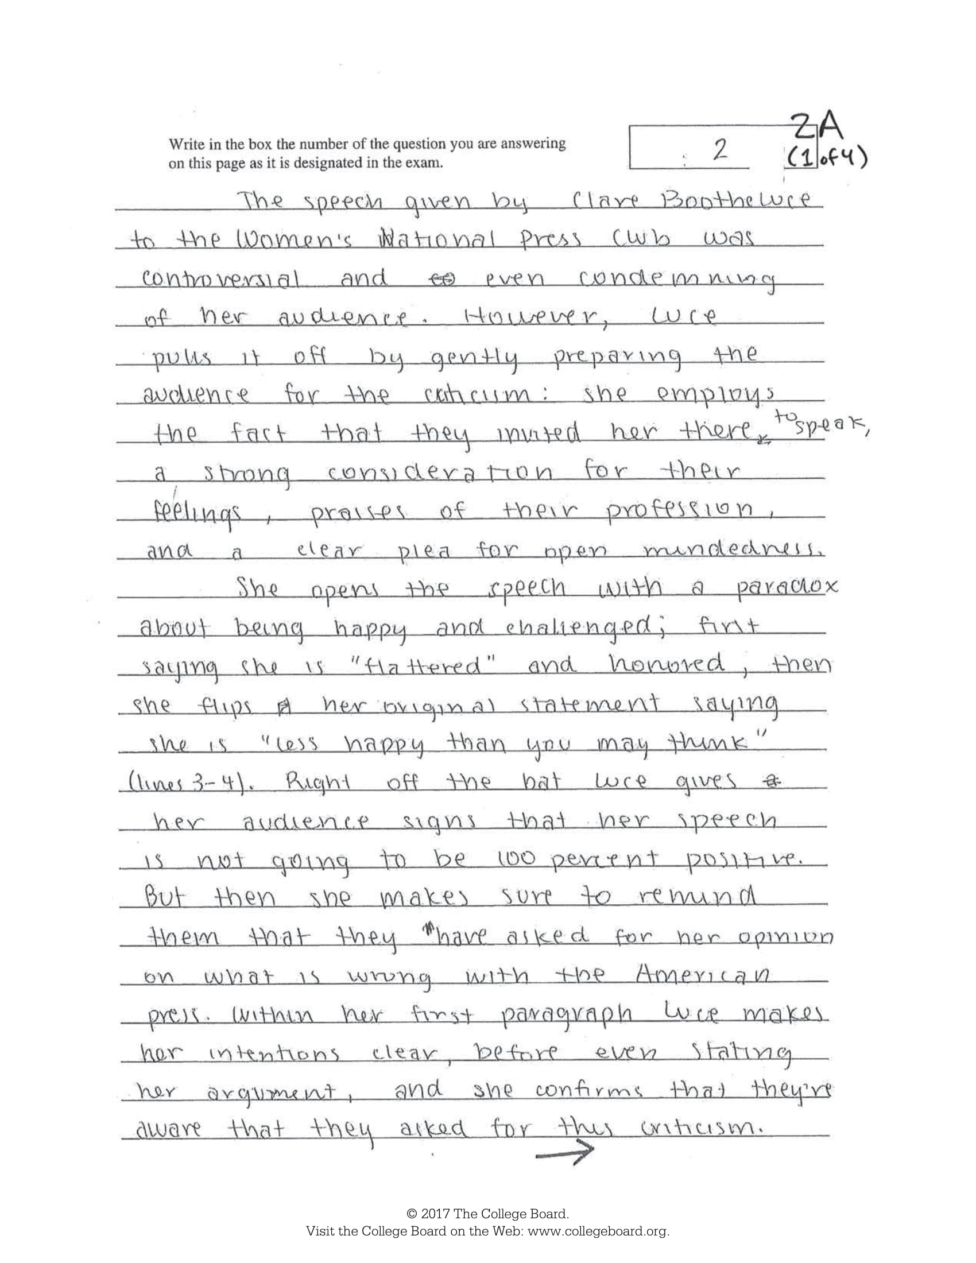

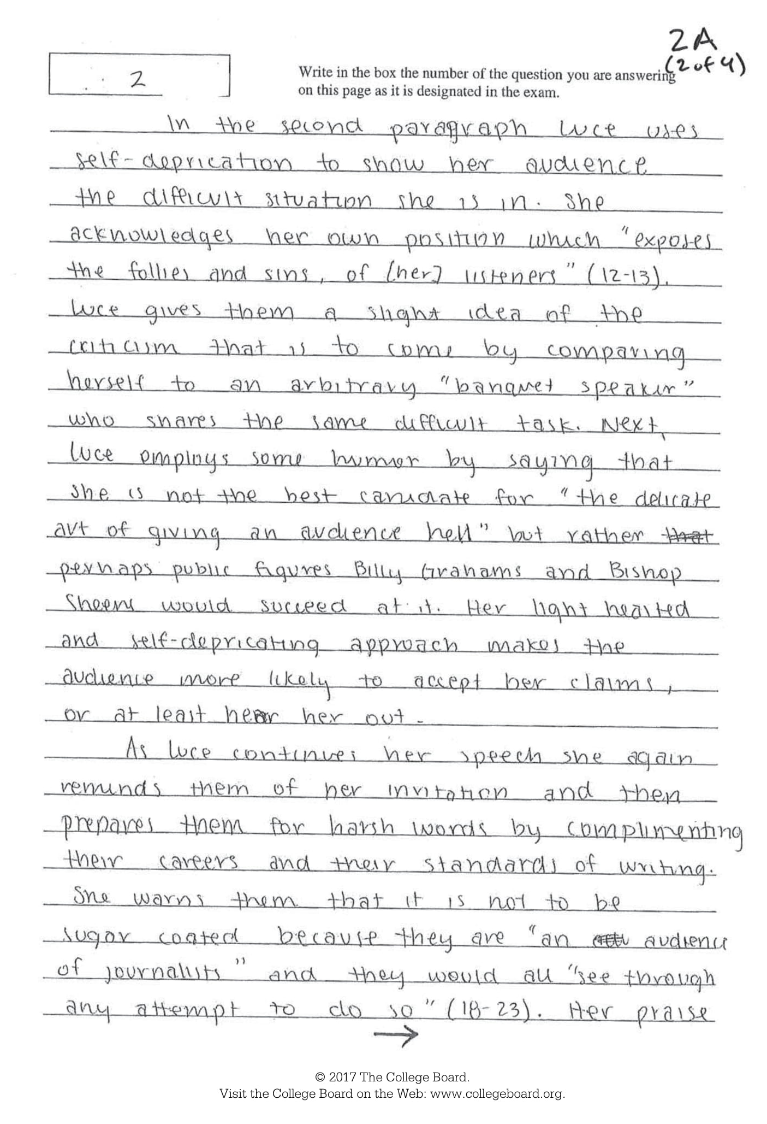
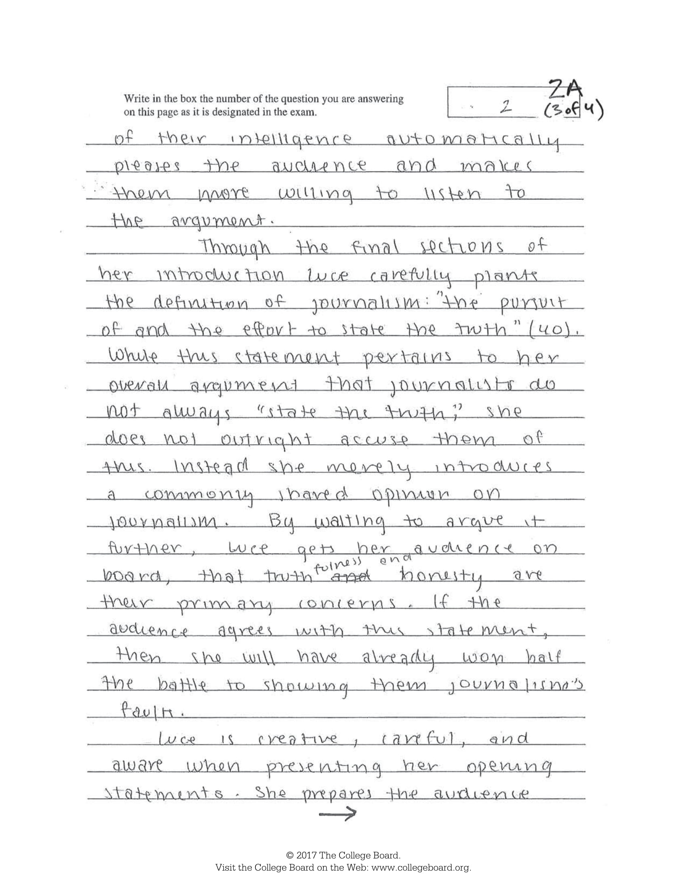
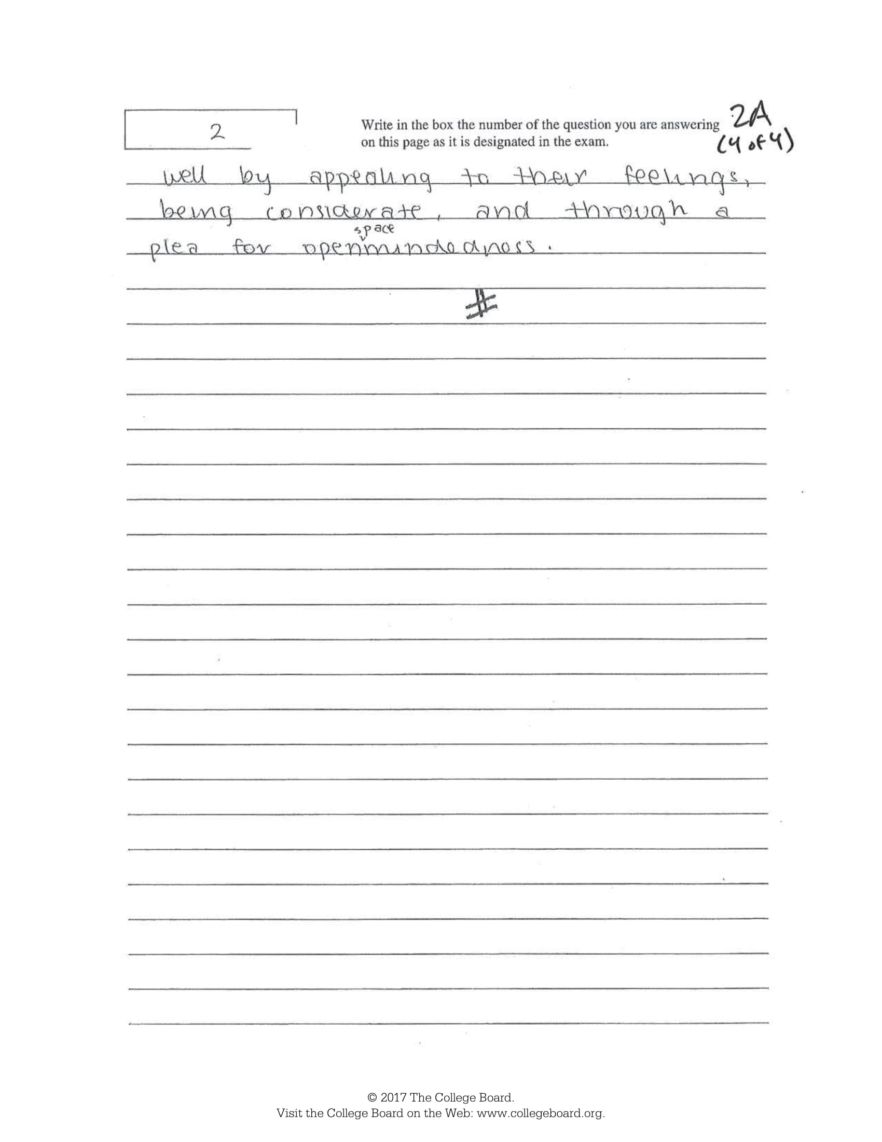

What should a rhetorical analysis essay do?

A PERFECT* rhetorical analysis essay will need to answer all of the following questions.
- What is the situation described by the author of original piece?

- Who is the writer/author/speaker?

- What is the primary goal of the analyzed piece of text?

- Who is the author's target audience (age, nationality, gender, preferences, location, interests, and other factors)?

- How does the content of the main message sound?

- Do the overall form and content correspond?

- Is the main idea successfully conveyed to that audience?

- What does the nature of communication tell about the culture that developed it?

See how many of them your sample essay answers. Provide quotes and citations (paragraph numbers) under each question corresponding to where you see that addressed in the sample essay.
*Keep in mind – No one expects a perfect essay. Not me. Not Collegeboard. Just do your best to address as many of these as possible in the time you have.
AP Test Practice Essay

In the June 1862 issue of The Atlantic Monthly magazine, American author and philosopher Henry David Thoreau published his essay “Walking.” The essay is considered to be a classic expression of American transcendentalism, a nineteenth-century philosophical, literary, and social movement that was skeptical of conventional social institutions and fearful of the changes wrought by industrialism. Transcendentalists such as Thoreau extolled self-reliance and encouraged a profound engagement with the natural world, which they sought to preserve in its pristine state. Read the passage carefully. Write an essay that analyzes the rhetorical choices Thoreau makes to convey his message about the value of walking in nature.
In your response you should do the following:
- Respond to the prompt with a thesis that analyzes the writer’s rhetorical choices.
- Select and use evidence to develop and support your line of reasoning.
- Explain how the evidence supports your line of reasoning.
- Demonstrate an understanding of the rhetorical situation.
- Use appropriate grammar and punctuation in communicating your argument.
When we walk, we naturally go to the fields and woods: what would become of us if we walked only in a garden or a mall?1 Even some sects of philosophers have felt the necessity of importing the woods to themselves, since they did not go to the woods. “They planted groves and walks of Platanes,”2 where they took subdiales ambulationes3 in porticos open to the air. Of course it is of no use to direct our steps to the woods, if they do not carry us thither. I am alarmed when it happens that I have walked a mile into the woods bodily, without getting there in spirit. In my afternoon walk I would fain forget all my morning occupations and my obligations to society. But it sometimes happens that I cannot easily shake off the village. The thought of some work will run in my head and I am not where my body is—I am out of my senses. In my walks I would fain return to my senses. What business have I in the woods, if I am thinking of something out of the woods? I suspect myself, and cannot help a shudder, when I find myself so implicated even in what are called good works—for this may sometimes happen.
My vicinity affords many good walks; and though for so many years I have walked almost every day, and sometimes for several days together, I have not yet exhausted them. An absolutely new prospect is a great happiness, and I can still get this any afternoon. Two or three hours’ walking will carry me to as strange a country as I expect ever to see. A single farmhouse which I had not seen before is sometimes as good as the dominions of the King of Dahomey.4 There is in fact a sort of harmony discoverable between the capabilities of the landscape within a circle of ten miles’ radius, or the limits of an afternoon walk, and the threescore years and ten of human life. It will never become quite familiar to you.
Nowadays almost all man’s improvements, so called, as the building of houses, and the cutting down of the forest and of all large trees, simply deform the landscape, and make it more and more tame and cheap. A people who would begin by burning the fences and let the forest stand! I saw the fences half consumed, their ends lost in the middle of the prairie, and some worldly miser with a surveyor looking after his bounds, while heaven had taken place around him, and he did not see the angels going to and fro, but was looking for an old post-hole in the midst of paradise. I looked again, and saw him standing in the middle of a boggy stygian5 fen, surrounded by devils, and he had found his bounds without a doubt, three little stones, where a stake had been driven, and looking nearer, I saw that the Prince of Darkness was his surveyor.
I can easily walk ten, fifteen, twenty, any number of miles, commencing at my own door, without going by any house, without crossing a road except where the fox and the mink do: first along by the river, and then the brook, and then the meadow and the wood-side. There are square miles in my vicinity which have no inhabitant. From many a hill I can see civilization and the abodes of man afar. The farmers and their works are scarcely more obvious than woodchucks and their burrows. Man and his affairs, church and state and school, trade and commerce, and manufactures and agriculture, even politics, the most alarming of them all,—I am pleased to see how little space they occupy in the landscape. Politics is but a narrow field, and that still narrower highway yonder leads to it. I sometimes direct the traveler thither. If you would go to the political world, follow the great road—follow that market-man, keep his dust in your eyes, and it will lead you straight to it; for it, too, has its place merely, and does not occupy all space. I pass from it as from a bean-field into the forest, and it is forgotten. In one half-hour I can walk off to some portion of the earth’s surface where a man does not stand from one year’s end to another, and there, consequently, politics are not, for they are but as the cigar-smoke of a man.

Final Yearbook Assignment

**Most of you have not yet submitted the last round of assignments. Thank you to the couple of you who have**

Your final assignment is going to help flesh out the faculty/staff section, as we now have some extra room in the spreads. I’ve assigned you each faculty members (flip to the back of this page). You are going to, in 1-2 (school appropriate) sentences, describe what you think these teachers are doing during quarantine. Use last names for teachers in order to receive credit and feel free to get silly with this.

Please let me know ASAP if I’ve forgotten anyone!

IMPORTANT – I am not as nice as Ms. Cassie and I will not be like her and waste my time hunting you down after graduation. Students who have not completed/sent in senior quotes, wills, baby pictures, superlatives, quarantine pictures, and other assignments by May 13 will receive no credit for them and will not have those things in the yearbook next year.

You may sent pictures and other content to me at charity.jones@k12.wv.us

Natalie- Mr. Armentrout
Emily- Mrs. Lane and Mrs. Terry
Allison- Ms. Jones and Mr. Nestor
Alex- Mrs. Mullennex and Jerry
Allen- Mr. Kelly and Mrs. Casey
Braydan- Ms. Josimovich and Ms. Ellswood
Peyton- Mr. Davis and Charlotte Armentrout
Michael- Kelly Teter and Melinda White
Kylie- Ms. Hawkins and Ryan Sites
Dallas- Patty Teter and Melanie Paugh
Shane- Kristin Teter and Cassie Atkins

