Art Packet #17-21 (Middle School)
Day #17: Plant Rubbing
Today I want you to find some leaves and flowers to do a rubbing. A rubbing is when you lay something under your sheet of paper then use the side of a pencil or a crayon to rub over it to leave its texture on your paper. Fill up your paper with lots of different types of leaves and flowers. Crayons will be best, but you could use a pencil too.
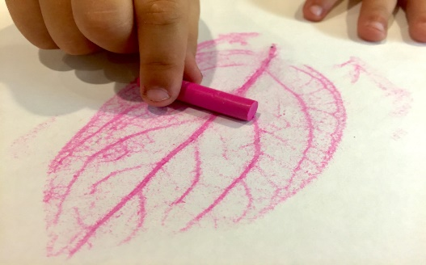
Day #18: Shadow Tracing
You will need to go outside on a sunny day for this project. Take a piece of paper and anything you want to trace with (pencil, colored pencil, crayons, or marker) outside to a tree. You will place the paper on the ground where the tree is casting a shadow. Now you just trace the shadow as it appears on your paper.
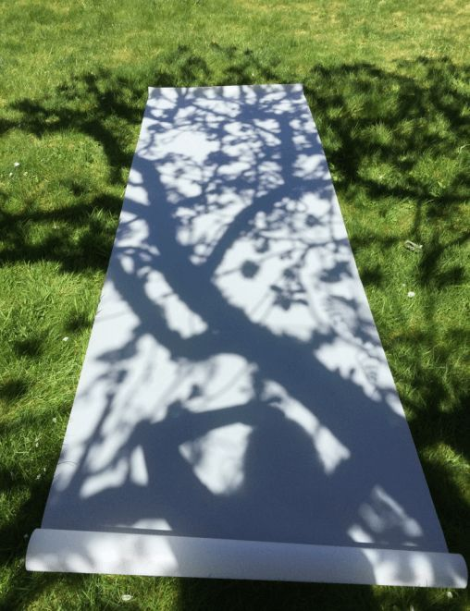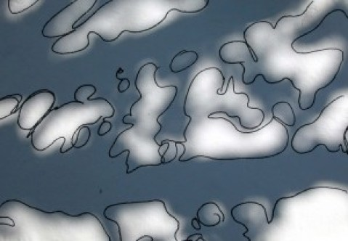
Day #19, 20, 21: Silly Method Drawings
I want you to try to draw the picture of the dog below as best you can by using three silly methods: drawing with your non-dominant hand, your feet, and your mouth. You will have three separate drawings of the same dog, but each will be done using a different method. Using your non-dominant hand means you draw with the hand you don’t normally use. Using your feet means you put the pencil between your toes and try to draw. Using your mouth means you put the pencil in your mouth and try to draw. Each of these will be a challenge, and it will be fun to see how the pictures differ. Also, make sure to wash your pencil after using it with your feet and mouth…yuck!
